**Advanced Database Management System**

**Assignment 1.1**

**Type:** Individual Student **Marks:** 5 **Last Date of Submission:** 11 Sept 2022

**Name of the student**………………………. **Class Roll No…………………………………**

***Note: Submit the assignment in A4 sheets only(hand written). Do not copy from each other (if assignment found to be copied, zero marks will be awarded to all such assignment).***

Ques. 1. One of the common misuses of spreadsheets is as a substitute for a database. Do you agree with this statement yes or no, justify your answer?

Ques.2. A company’s sales department stores a sales representative’s name as “Bill Brown” and the company’s HR department stores that same person’s name as “William G. Brown,”. Identify the problem in above description and why does it occurs and what is the solution to such problems.

Ques.3. Give examples of systems in which it may make sense to use traditional file processing instead of a database approach.

Ques. 4. What is the difference between logical data independence and physical data independence? Which one is harder to achieve? Why?

Ques.5. List five responsibilities of a database administrator. For each responsibility, explain the problems that would arise if the responsibility were not discharged.

Ques.6. Explain the difference between two-tier and three-tier architectures. Which is better suited for Web applications? Why?

Ques.7. Table 1

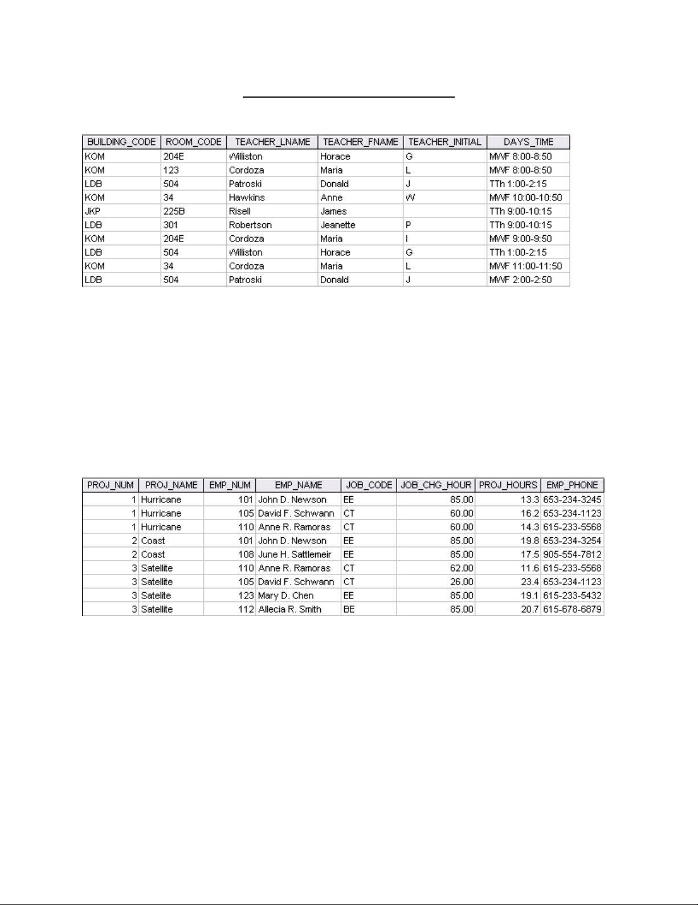**Given the file structure shown in Table 1, answer Problems 1-4.**  
1. What data redundancies do you detect? How could those redundancies lead to anomalies?

2. Identify and discuss the serious data redundancy problems exhibited by the file structure shown in table 1.  
3. Looking at the EMP_NAME and EMP_PHONE contents in table 1, what change(s) would you recommend?  
4. Identify the various data sources in the file you examined in Problem 2.  
5. Given your answer to Problem 4, what new files should you create to help eliminate the data redundancies found in the file shown in table 1?